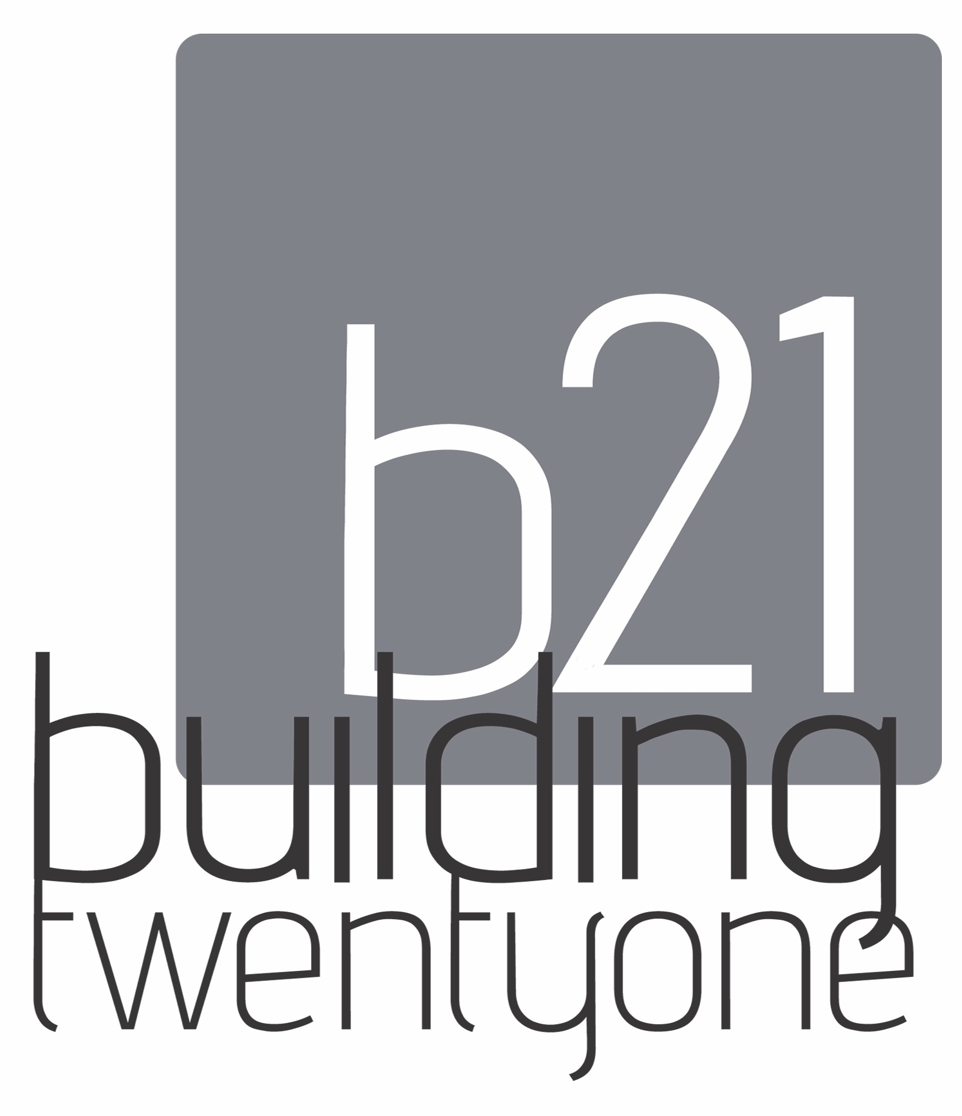

Building TwentyOne Volunteer Application 2017

Organization/Group Name: _____________________________________________________
Contact Person Information:
Name:__________________________________Email: ________________________________
Phone:__________________________
Local Address:__________________________City:___________State:______Zip:_________
Description of organization/group:
______________________________________________________________________________
______________________________________________________________________________
______________________________________________________________________________
Why does your organization want to volunteer at B21?_______________________________
______________________________________________________________________________
______________________________________________________________________________
Is this organization looking for a one time volunteer experience or recurring?
______________________________________________________________________________
Please provide specific dates and/or days and times of the week your group is able to work
Dates:________________________________________________________________________
Sunday | Monday | Tuesday | Wednesday | Thursday | Friday | Saturday

Statement Agreement:
I will not hold the Building TwentyOne accountable for any injury that might occur to me throughout my work as a volunteer. I grant permission for the Building TwentyOne to contact any listed references and to review a comprehensive background check.

Volunteer Signature: ______________________________________ Date:________________

Thank you for your interest! A Building TwentyOne staff member will contact you soon.
Submit to: Building TwentyOne, c/o My Ha, 1288 N Cedar St. Mason, MI 48854
or email to: my@buildingtwentyone.com

